1. Here is the source code:

<https://github.com/eazybytes/microservices-with-spring/tree/main/accounts>

1. Agenda:
   1. How to create microservice specific to accounts.
2. 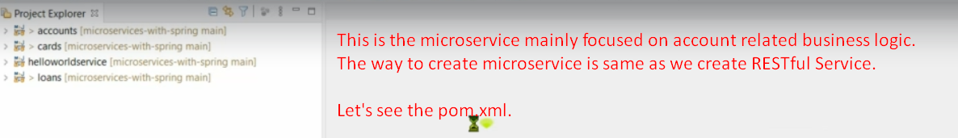  
   The process is similar as creating Spring Boot App using start.spring.io website.
3. 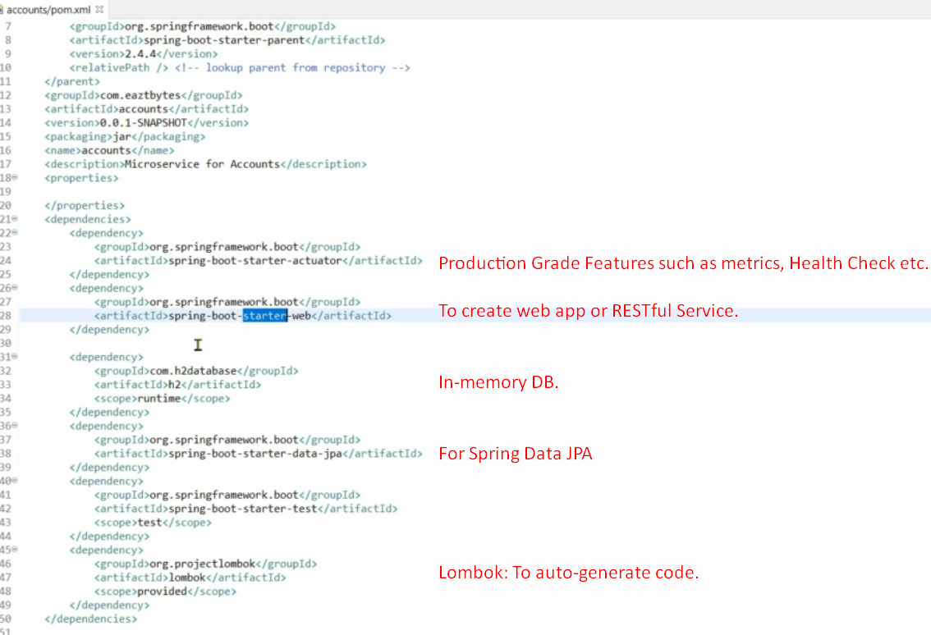  
   Embedded Tomcat and In-memory H2 DB are the features which can be used to show something to someone quickly like POC.
4. 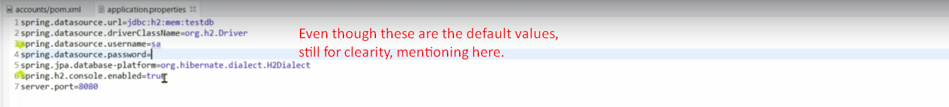  
   The above H2 connection info is default values but still we mentioned for you to see and in case you want to change, you can do it.
5. Let’s see the main class inside this project related to accounts micro service.  
   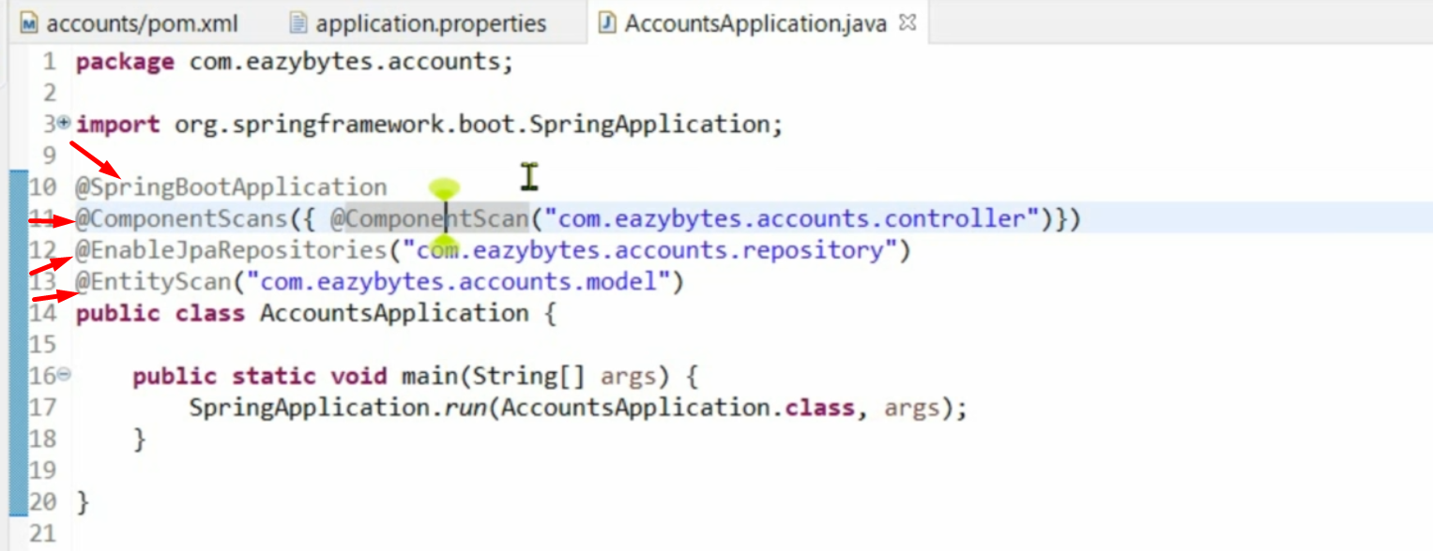
6. 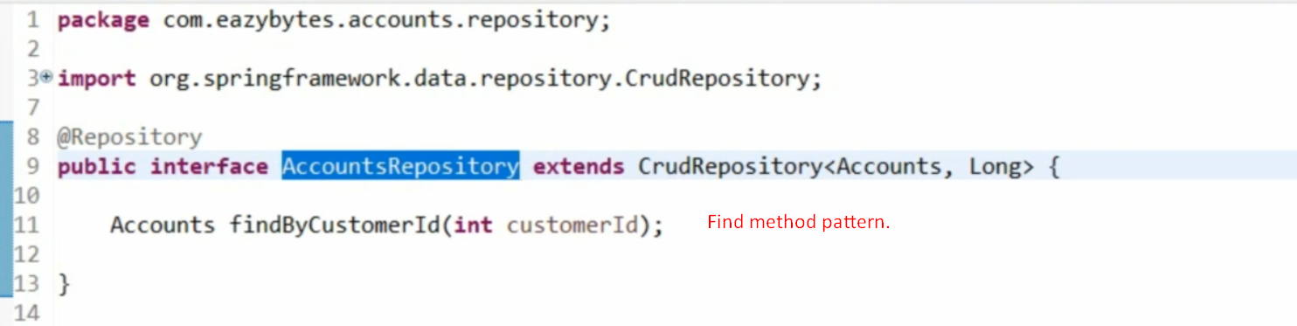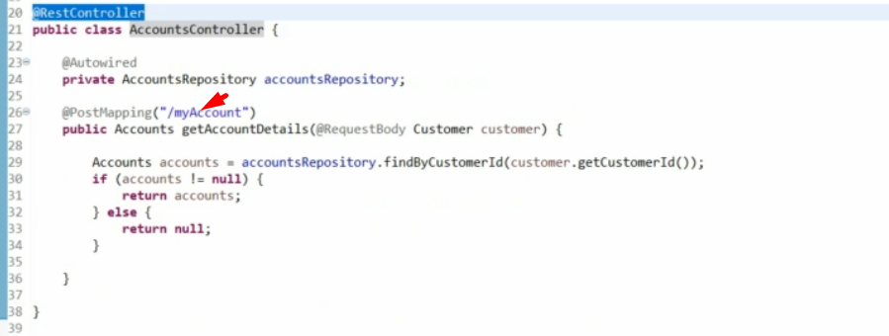
7. 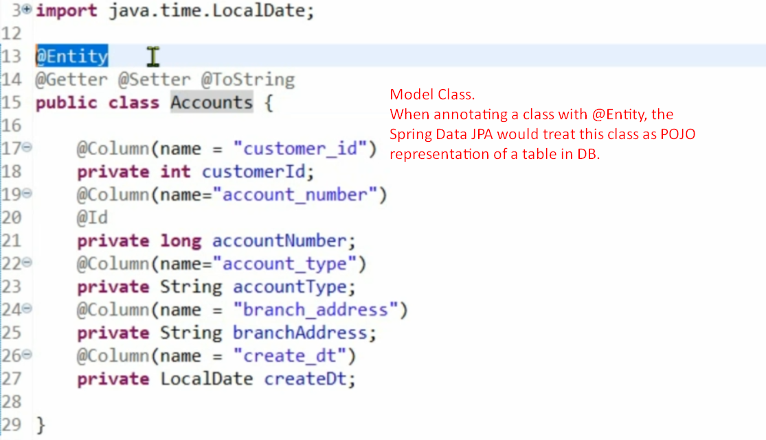
8. 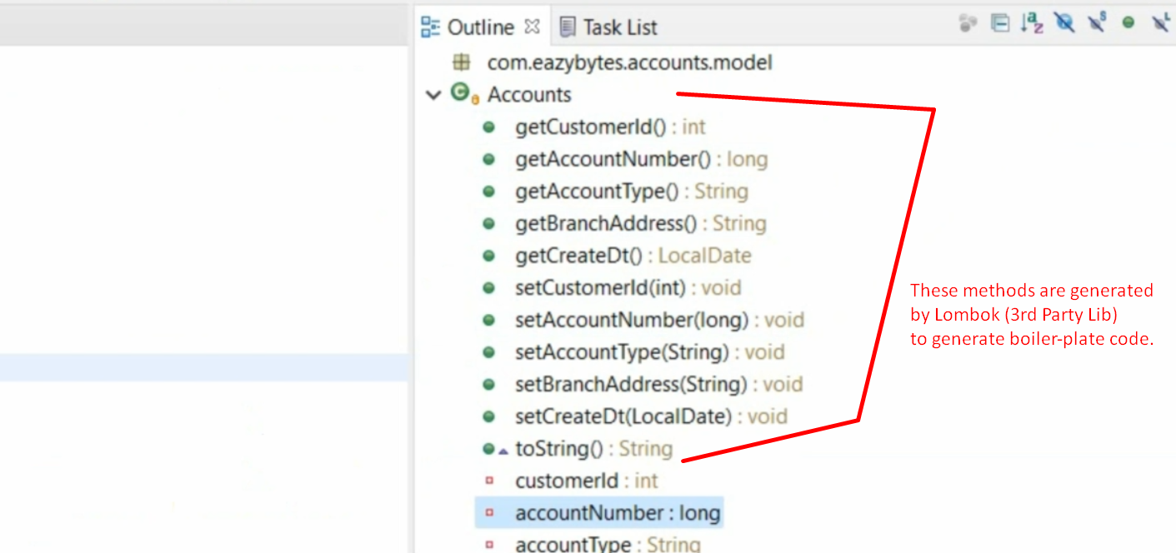
9. 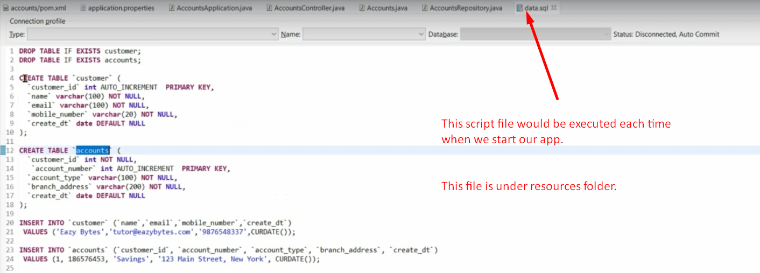
10. 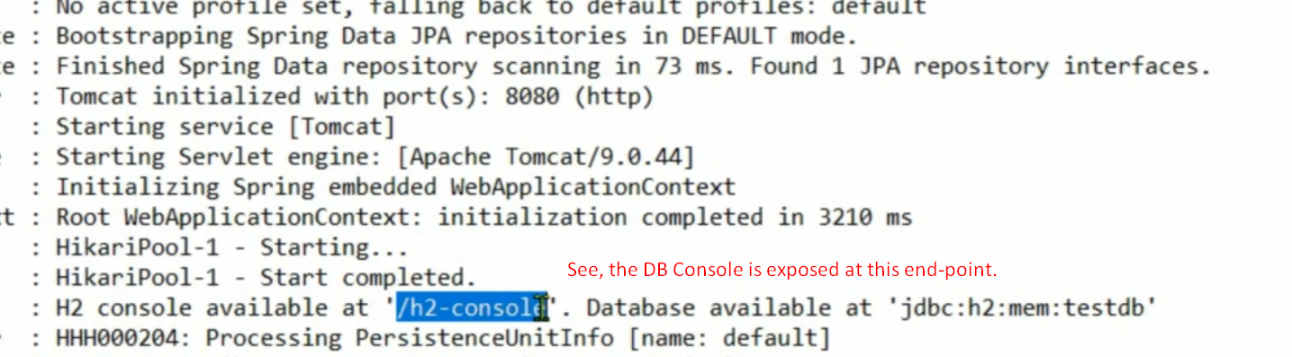
11. 
12. 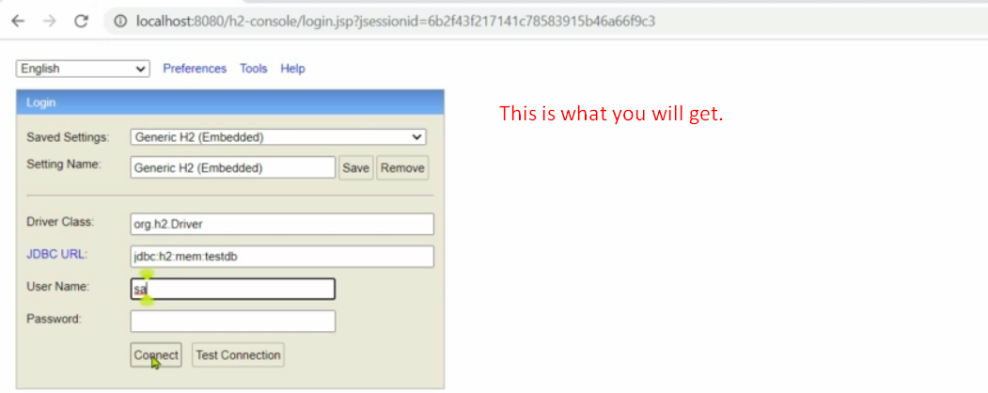
13. 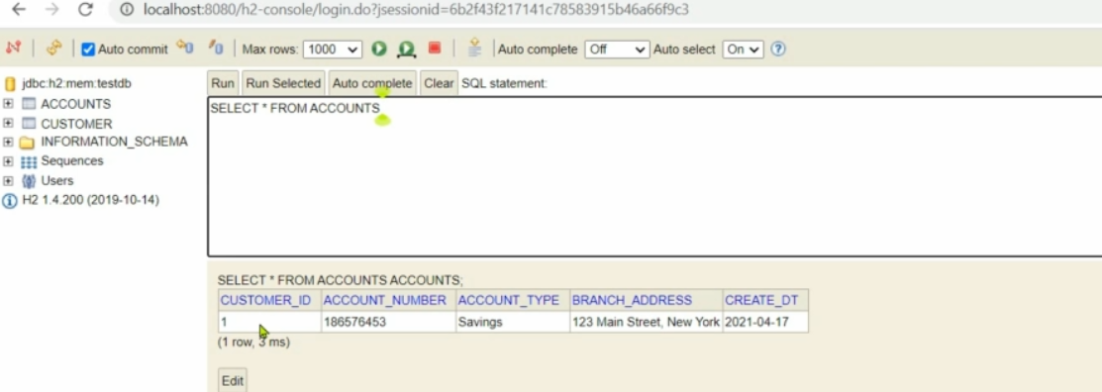
14. 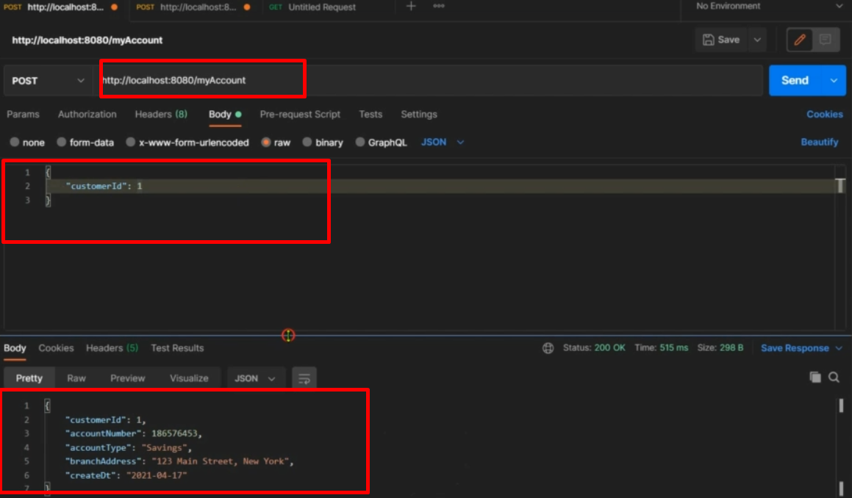
15. See, how easily we created account related microservice.
16. Along the journey, see the power of Spring Boot.
    1. How to deploy the app into a separate server.
    2. There are many starter project which cares about the dependencies and configuration.
    3. You don’t need to do much configuration.
    4. Annotations provide so much facilities such as Spring automatically identities beans, configure them, auto-wire them.